**Programming Assignment 2**

EE548: Matrix computations for signal processing

Due date: ~2023/04/09, 23:59

1. Introduction

In this assignment, you will implement a norm function and a condition number function. For detailed requirements, please follow the comments in the MATLAB file. The parts of the code you need to implement are marked in the comment as ‘Write down your code in the following block’.

1. Specifications

Language: MATLAB

Files:

* *norm_ord.m, norm_vec.m, norm_mtx.m*: Your custom norm function for vector/matrix
* *cond_num.m*: Your custom condition number function
* *test1.m*: Compare the custom functions with MATLAB's built-in function. You should submit the resulting table of this code. Do not modify this file
* *test2.m*: Compare the sensitivity of a linear system in terms of the condition number. Details are below. Do not modify this file

1. Submission
2. Explain your answer with a single pdf file, which should include follows:
   1. Code implementation
   2. The power iteration method for obtaining the largest singular value of a matrix is implemented in *norm_mtx.m*. Explain the reason along the code why such method works
   3. Screenshot of resulting table of *test1.m*
   4. Explain the result of *test2.m* in terms of the condition number.
3. The final submission would be a single zip file containing a single pdf file and all the matlab files. The name of the zip file should be ‘ID_name.zip’, e.g. 20223303_SeoungbinBae.zip

4. Details of *test2.m*

1. *test2.m* shows the sensitivity of the linear system $Ax=b$ ($A∈R^{n×n}, b∈R^{n×1}$) when $b$ is getting perturbed by standard normal random noise $e$. Therefore, $A\hat{x}=b_{e}$ ($b_{e}=b+e$).
2. The high value of the $A$’s condition number, which is $κ(A)$, can cause a large change between the ground truth answer $x$ and the estimated answer $\hat{x}$
3. One way to reduce the condition number is to add the identity matrix while inverting $A$ to solve the equation as follows:
 $\hat{x}={\left(A^{H}A+λI\right)}^{-1}A^{H}b_{e}$

  1. When $λ=0$, we can see that it is the same as the general method of obtaining the solution of the linear system: $\hat{x}={\left(A^{H}A\right)}^{-1}A^{H}b_{e}=A^{-1}A^{H^{-1}}A^{H}b_{e}=A^{-1}b_{e}$
   2. We will look at a boxplot of how the error of the estimated answer (${\left|\left|x-\hat{x}\right|\right|}_{2}$) changes by increasing the value of $λ$ by 0.1 from 0.0 to 0.4.

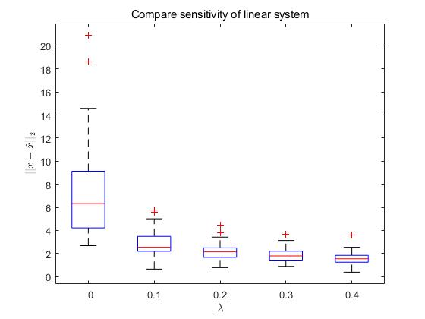

1. If $σ_{max}\left(A\right), σ_{min}\left(A\right)$ is the maximum/minimum singular value of the matrix $A$, the condition number of the 2-norm $κ_{2}\left(A\right)=κ_{2}\left(A^{-1}\right)={\left|\left|A\right|\right|}_{2}{\left|\left|A^{-1}\right|\right|}_{2}=σ_{max}\left(A\right) σ_{min}\left(A\right)$.
2. Represent $κ_{2}\left({\left(A^{H}A+λI\right)}^{-1}A^{H}\right)$ in terms of $σ_{max}\left(A\right), σ_{min}\left(A\right)$ and $λ$, and then guess what happened to $κ_{2}\left({\left(A^{H}A+λI\right)}^{-1}A^{H}\right)$ as $λ$ increases. (hint: using SVD, $UΣV^{H}=A$, ${UU}^{H}=U^{H}U=VV^{H}=V^{H}V=I$, and $Σ$ is nonnegative real diagonal matrix)